**Interfaces Group 1 of WP3 :**

Remind architecture yet described in « Papyrus » :

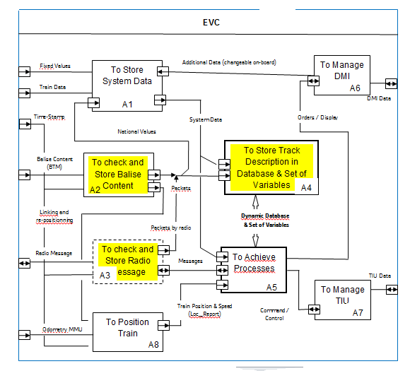

Comments :

* A1 : To Store System Data :

This box is a general purpose which gathers all parameters such as :

“Train Data” that are defined during the on-board data preparation,

“Fixed Values” that are generic,

“National Values” that come from transmission ( or trackside) and

“Additional Data” that can be defined by the driver.

* A2 : To Check and Store Balise Data :

This box deals with :

All data received by BTM and transmitted to EVC,

Computation of exact train position through MMU and Time stamping.

* A3 : To Check and Store Radio Messages :

All data transmitted by Radio and transmitted to EVC,

Computation of exact train position through MMU and Time stamping.

* A4 : To Store Track Description in Database :

Database is managed through elementary functions:

To store packets into one or several events,

To withdraw,

To keep in order .

Description is given later on.

* A5 : To Achieve Processes :

The list of processes is given later on.

* A6 : To Manage DMI :

All processes to display to driver or receive from.

* A7 : To Manage TIU :

All processes to order to train or receive from.

* A8 : To Position Train :

To acquire data from odometer,

To position train in database ( Max and Min Front End, Antenna).

“Speed and Distance Monitoring” is a part of box A5 :

The final breakdown structure of IBD “second level” could be established as hereafter, by distinguishing mandatory and secondary functions.

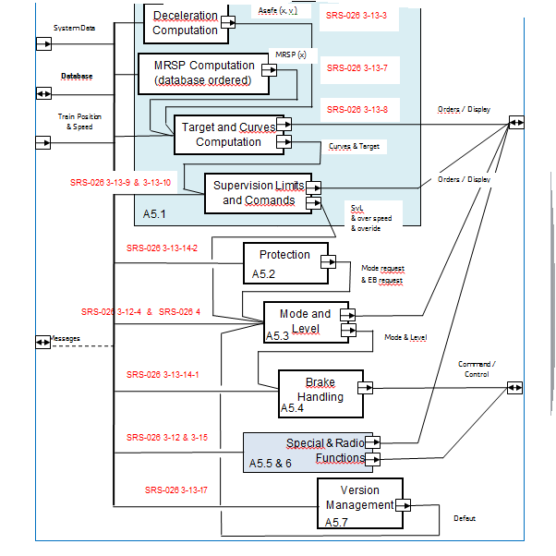

* A5.1 : Speed and Distance Monitoring :
  + A5.1.1 : Deceleration( x, v ), Build-up Time, Gradients, Rotating Mass computation,
  + A5.1.2 : MRSP(x ) computation (Most Restrictive Speed Profile),
  + A5.1.3 : Targets and Curves computation, MRDT (Most Restrictive Displayed Target),
  + A5.1.4 : Supervision Limits computation (SvL, Ceiling, Target, Release),
  + A5.1.5 : Commands of Speed and Distance Monitoring.
* A5.2 : Protection :
  + A5.2.1: Emergency Stop (UES, CES, revocation, inhibition)
  + A5.2.2 : Track ahead Free,
  + A5.2.3 : MA Shorten,
  + A5.2.4 : Roll Away Protection,
  + A5.2.5 : Reverse Movement Protection,
  + A5.2.6 : Standstill Supervision.
* A5.3 : Mode and Level Monitoring :
  + A5.3.1: Level Handling,
  + A5.3.2 : Mode Handling.
* A5.4 : Brake Command Handling.

**Database Objectives and Principles :**

* To permit communication between “Technical Functions” (boxes A2, A3, A8) and “Operational Functions” (box A5).
* To decompress trackside data in order to permit computation related to train position and speed.
* To have a common “Coordinate System” for all functions.
* To have a common “Coordinate System” between trackside and train-borne.

Positioning is based on an “Absolute Counter” of odometer which is composed of three values in reason of multiple inaccurate sources of odometer sensors :

* Nominal value : given by current nominal counter of odometer.
* Maximum value : given by maximum counter of odometer.
* Minimum value : given by minimum counter of odometer.

**Basic Positioning :**

All these values are corrected by an estimation of run distance during elapsed time between odometer and EVC . This estimation is achieved through time stamp and odometer speed estimation. Maximum and Minimum value must be within range of +/-5% of Nominal value between two BG. This correction is : Delta_T * V_est.

All these values are set to zero at power up and are never reset until power cut. Meanwhile, when overpassing one new LRBG, maximum and minimum are reset to nominal value (+/- balise position inaccuracy), by keeping in memory the 3 counters current value for use later on.

* Nominal LRBG value : nominal value when overpassing last LRBG.
* Maximum LRBG value : maximum value when overpassing last LRBG.
* Minimum LRBG value : minimum value when overpassing last LRBG.

When no linking is used, only the checking of 5% is taken into account and the 32 bits odometer counter is used to position any event in database. Correlation between 32bits counter and address is achieved modulo ”N”. Example :

* Quantum = 5 m,
* Distance since power-up = 1000 km = 10exp6 m,
* Address modulo 1K = (10exp6 / 5) modulo [ 1024] = 320 = 140H,
* Coverage Maximum = [ 1024] * 5 = 5,12 km

**Positioning with “Linking” :**

When overpassing a linked balise group with linking available, this BG has a double position :

* Odometer counter when overpassing the BG,
* Anticipated counter through previous BG counter position increased by “D_Link”.

A “Algorithm” is involved to choice between both, each counter having its own window value.

Basically, anticipated counter should be chosen when D-Link is free of error while odometer counter is disturbed by sensor inaccuracy. The result is so-called “Estimated Position” and window limits are so-called Max-Safe-Front-End and Min-Safe-Front-End.

As long as linking is available, the estimated position is the sum-up of D-link value.

When linking is no longer available, odometer counter is again the odometer reference.

**Chronogram about reading of BG :**

Cn-1

Cn+1

Cn

D_link(n)

D_link(n+1)

BGn-1

BGn

BGn+1

When passing over BGn-1 :

* Odometer counter is Cn-1
* Data attached to BGn-1 are positioned at [Cn-1 + x] because no linking is given for BGn-1
* BGn will be expected at [Cn-1 + D_link(n)]

When passing over BGn :

* Odometer counter is Cn, BGn and Cn become the reference :
* BGn is seen in advance related to odometry counter = Delta
* Delta = [Cn-1 + D_link(n) - Cn]
* Data attached to BGn are positioned at [Cn + x + Delta]
* **
* BGn+1 will be expected at [Cn + D_link(n+1)]

**DataBase Build Up :**

As yet described in the previous document, the build-up is achieved in 3 phases :

Phase 1 : Event are extracted from BG telegram or Radio message, two cases must be envisioned :

* The event being the first LRBG : no special caution,
* The event being a new LRBG : old event have to be swept following type (for instance, a new MA requires cancelation of SSP, grade profile, but TSR is saved) .

In any case, the odometer counter permits to calculate the BG address modulo the database size.

Phase 2 : From Train Position up to SvL, calculate MRSP, A_Gradient and K_Adh from event positioned in phase 1, by using all System Data as necessary.

Phase 3 : Calculate Curves.

**DataBase Use :**

As long as no new BG or new radio message are to be taken into account, the database is frozen

The curves calculated in phase 3 are used through “Train Position” and “Train Speed”. See “X0” on diagram, V0 being the triggering emergency brake of EBI curve.

The monitoring mode (CSM, TSM, RSM) and status (normal, indication, permit, warning, over speeding, intervention, SB, EB) are calculated by using curves and train speed and position.

**Database Synopsis :**

Position Type DOT. Data1 Data2 MRSP AGrd K_Adh Target EB_ G_ K_ Corr_ENER

Energy Computation :

EBD, EBI, SBD,

SBI1, SBI2

DMI curves : W, P, I

See Events Definition

Preliminary Computation

Follows odometry

(step = 5 m )

Train Running Direction

Data from Packets

(used for preliminary computation)

**Speed Control process :**

Three modes are involved :

* Ceiling Speed Monitoring : this is the phase when speed is stable (CSM).
  + CSM is characterized by one berthing speed and one allowance of overspeeding.
  + Berthing Speed is so-called the Permitted Speed.
  + Berthing Speed plus Allowance defines the EBI (Emergency Brake Intervention).
  + No EBD is defined.
* Target Speed Monitoring : this is the phase when speed is reduced (TSM).
  + TSM is characterised by one target speed or reduction speed and a deceleration.
  + Both target and deceleration define the EBD (Emergency Brake Deceleration).
  + Deceleration is a function of MRSP.
  + A model is involved to take into account all response time related to breaking.
  + Modelisation can be approached through two ways :
    - for a given position “X0”, to calculate the related speed “V0” for all curves (EBD, IBD, SBI, W, P). This is the preferred solution.
    - for a given speed “V0”, to calculate the related position “X0” for all curves. This is the SRS description.
* Release Speed Monitoring : this is the phase when approaching a stop (RSM).
  + RSM is characterised by a release of EBI curve which is replaced by an override control at the EOA.
  + This release is defined by a so-called release speed whose value depends on distance from EOA to DP.

**Speed Control Model in Excel :**

Modelling requires the following variables :

* Position : location per quantum of 10 m.
  + Choice of decreasing position is done,
  + The EOA is supposed to be at position 0 of the turning buffer,
  + Any other position can be done for EOA.
* Vc : EBD curve is starting from a target defined by a couple {X1, V1}.
  + X1 = position of target,
  + V1 = speed reduction of MRSP,
  + EOA is initial target,
  + Curve is computed by step of 10 m with : V(i+1) = SQRT [ V(i) ² + (2*Asafe(i) *10)]
  + Scanning is achieved from farther target up to train position,
  + Vc’ : EBD curve for IBD is extended EBD curve in ceiling speed monitoring,
  + Target with speed above EBD are ignored.
* Asafe : deceleration in m/s² for emergency braking curve.
  + Asafe = Aeb + Agrad /Alpha.
  + Aeb = emergency brake deceleration value,
  + Aeb = function of MRSP speed and Position (5 values maximum),
  + Agrad = acceleration / deceleration value due to slope and gravity,
  + Agrad = p * 9.81 with p>0 in uphill and p<0 in downhill, taking in account worse case over train length,
  + Alpha = coefficient of turning mass, acting as amplifier on mass in movement,
  + Alpha = 1.xx with 4% < xx < 15%.
* MRSP : compile SSP, ASP, Veoa, Vrelease, TSR, in m/s,
  + dV : delta speed for MRSP allowance,
  + MRSP+dV : includes dV to define EBI in ceiling speed monitoring.
* VT : target speed = last speed reduction when reading from EOA toward train position,
  + VT is taken into account when VT = V0 or VT < V0.
* TSM : target speed monitoring,
  + TSM = true when Vc’ < MRSP + dV,
* Dbec : See drawing :
  + DT : T1 + T2 ,
    - T1 is Ttraction, or duration of Aest1,
    - T2 is Tberem, or duration of Aest2,
  + DX : used to calculate Dbec : V0 * DT + DX,
  + DV : is equal to : (T1*Aest1) + (T2*Aest2).
* Second Degree Equation : a*x² + b*x + c,
  + a = 1,
  + b : coefficient “b”,
  + c : coefficient “c”,
  + D : discriminant = b² - ( 4*a*c )
* V0 : EBI speed,
  + Solution of Second Degree Equation,
  + V0 = [ SQRT( D) – b ] / 2,
  + Vbec : EBI speed + DV.

**Diagram Distance versus Speed Control :**

Dbec

Delta V

Vbec = f( Dbec, Asafe)

V0 = Vb – Delta_V

Xb

X0

X1

V1

Vc = f( X0, X1, V1, Asafe)

**Computation of EBD curve and EBI curve through V0 = Function( X0 )**

Vc² = V1² + 2*(X1-X0)*Asafe = **f(X0, X1, V1)**

Delta_V = (Aest1 * T1) + (Aest2 * T2) = **DV**

Dbec = ½ (Aest1*T1² + Aest2*T2²) + (Aest1*T1*T2) + V0*(T1 + T2) = **DX + (V0 * DT)**

Vbec² = Vc² – 2*Dbec*Asafe) ( 1st expression based on V1)

= Vc² - 2*Asafe*(DX + V0*DT) = V1² + 2*Asafe*(X1-X0-DX-(V0*DT))

Vbec² = (V0 + DV)² = V0² + 2*V0*DV + DV² ( 2nd expression based on V0)

**V0 solution = elimination of Vbec :**

**V1² + 2*Asafe*(X1-X0) – 2*Asafe*(DX + V0*DT) = V0² + 2*V0*DV + DV²**

**V0² + 2*V0*(DV + Asafe*DT) + 2*Asafe*DX + DV² - V1² - 2*Asafe*(X1-X0) = 0**

a = 1 b = 2*(DV + Asafe*DT) c = 2*Asafe*(DX+X0-X1) + DV² - V1²

D = ( b² - 4*a*c) / 2 a

V0 = [ - b + SQRT( D ) ] / 2 => **V0 = - (DV + Asafe*DT) + ½ SQRT(D**)

**Verification Invariant : DT = 0 must make V0 = Vc.**

DT = 0 => D = 4 * [ V1²/2 + Asafe*(X0-X1) ]

DT = 0 => V0 = ½ SQRT(D) = SQRT( V1² + 2*Asafe*(X0-X1) ) = Vc

« C »

« B »

« 0 »

« 1 »

« A »

**Computation of EBD curve and EBI curve through X0 = Function( V0 )**

**V0² + 2*V0*(DV + Asafe*DT) + 2*Asafe*DX + DV² - Vc² = 0**

Vc² = V1² + 2*(X1-X0)*Asafe

V0² + 2*V0*(DV + Asafe*DT) + 2*Asafe*DX + DV² = V1² + 2*Asafe*(X1-X0)

V0² - V1² + 2*V0*(DV + Asafe*DT) + 2*Asafe*DX + DV² = 2*Asafe*(X1-X0)

V0² - V1² + 2*V0*DV + DV² + 2*V0*Asafe*DT) + 2*Asafe*DX = 2*Asafe*(X1-X0)

(V0+DV)² - V1² + 2*Asafe*(V0*DT + DX) = 2*Asafe*(X1-X0)

(X1-X0) = [ (V0+DV)² - V1² ] / (2*Asafe) + (V0*DT + DX)

with V0 + DV = Vbec and V0*DT + DX = Dbec

(X1-X0) = [ Vbec² - V1² ] / (2*Asafe) + Dbec

**X0 = X1 - [ Vbec² - V1² ] / (2*Asafe) - Dbec**

**Then :**

**X0 = X1 - [ ( V0 + DV )² - V1² ] / (2*Asafe) - [ DX + ( V0 * DT) ]**

Problem : X0 = F(V0° is not a function because a same “V0” can provide several “X0”.

**Scope of WP3 group 1 :**

We need to come back to architecture datagram at the beginning of the present document.

The scope of “group 1” is limited to boxes A51 and A52 :

* A5.1 : Speed and Distance Monitoring, based on excel file n°400 and n°401 ( mode OS / FS) :
  + A5.1.1 : Deceleration( x, v ), Build-up Time, Gradients, Rotating Mass computation :
    - Computation of Asafe(x, v) with train characteristics, grade profile, adhesion factor and rotating mass coefficient,
    - Computation of build-up Time (variables DX, DT, DV).
  + A5.1.2 : MRSP(x ) computation (Most Restrictive Speed Profile) :
    - Computation of MRSP(x) and dV with Speed Profile (SSP and ASP), TSR, Max Train Speed and Max Signalling Speed.
  + A5.1.3 : Targets and Curves computation, MRDT (Most Restrictive Displayed Target) :
    - Computation of EBD curve based on MRSP(x) and Asafe(x, v),
    - Computation of Target (variables VT, XT),
    - Computation of Monitoring Mode (variable TSM),
    - v being equal to MRSP(x) + dV,
    - Scan starting from EOA or DP or OL.
  + A5.1.4 : Supervision Limits computation (SvL, Ceiling, Target, Release) :
    - Computation of SBI, W, P and I curves.
  + A5.1.5 : Commands of Speed and Distance Monitoring :
    - Taking in consideration the train position (X0), defines the speed limit for EB, SB, W, P and I,
    - Taking in consideration the train speed, defines the status and outputs (Trip, COP, SB, W, P, I).
* A5.2 : Protection (mode OS, FS, LS) :
  + A5.2.1: Emergency Stop (UES, CES, Revocation) by radio message :
    - UES (Unconditional Emergency Stop) is radio message n°16,
      * Is referenced by an Id and addressed to one train, without position,
      * Always taken into account by onboard,
      * Can be revocated by message n° 18,
      * Acknowledgement by message n° 147.
    - CES (Conditional Emergency Stop) is radio message n°15,
      * Is referenced by an Id and addressed to one train, with position,
      * Is taken in account if max-safe-front-end has not overpassed its position,
      * Can be revocated by message n° 18,
      * Acknowledgement by message n° 147.
  + A5.2.2 : Track ahead Free by radio message :
    - Track Ahead Free Request is sent to train by message n° 34,
    - Track Ahead Free Granted is sent back to wayside by message n° 149.
  + A5.2.3 : MA Shorten by radio message :
    - MA Shorten is requested to train by message n° 9,
    - a new position of EOA is provided by trackside,
    - Request to Shorten MA is granted by on-board with message n° 137,
    - Request to Shorten MA is rejected by on-board with message n° 138.
  + A5.2.4 : Roll Away Protection :
    - Movement in reverse direction is limited between 2 LRBG.
  + A5.2.5 : Reverse Movement Protection :
    - Reverse Movement are monitored by packets n°138 and n°139.
  + A5.2.6 : Standstill Supervision :
    - Standstill is provided by odometer,
    - is used to exit Trip Mode.

**Annex :**

Computation of MRSP( x) and Asafe( x, v) by starting from packet inputs.

Computation is based on one matrix of 2 dimensions :

First dimension = Position :

Odometer Counter Modulo S, S being size of turning buffer,

Quantum = 1 m, 5000 positions, coverage = 5 km.

Second dimension = Data related to MRSP and Asafe computation :

Data inputs : SSP, QF, Grad, ASP, Veoa, TSR, Adhesion, Aeb0, Aeb1, Aeb2, Aeb3,

Data outputs : MRSP(x), Asafe0(x), Asafe1(x), Asafe2(x), Asafe3( x).

LRBG

Pk B

EOA

Pk E

LRBG

Pk_A

**LRBG** SSP QF ASP Veoa TSR **MRSP** Grd Adh Aeb0, 1, 2, 3 **Asafe0, 1, 2, 3**

DOT

Other

Pk X

**LRBG** SSP QF ASP Veoa TSR **MRSP** Grd Adh Aeb0, 1, 2, 3 **Asafe0, 1, 2, 3**

**LRBG** SSP QF ASP Veoa TSR **MRSP** Grd Adh Aeb0, 1, 2, 3 **Asafe0, 1, 2, 3**

The train is somewhere between Pk_B (Last Relevant Balise Group) and Pk_E (Pk related to EOA).

**MRSP( x) computation :**

All received packets are distributed over the matrix :

SSP values according position (D_STATIC & V_STATIC), and according train length (QF),

ASP values,

Veoa value,

TSR values according position, TSR length and train length (option).

LRBG value is defined when overpassing linked BG :

SSP values are coming from packet n°27 :

ASP values are coming from packet n° 51 :

Veoa value is coming from packet n°12 or n°15 :

TSR values are coming from packet n°65 :

**Asafe( x) computation :**

All received packets are distributed over the matrix :

Grd values, uphill/downhill, compensated by train length,

Adh values, permiting to define four steps Aeb0, Aeb1, Aeb2, Aeb3.